
Date: 15/08/25

Dear Sir or Madam,

TENDER FOR LIVESTOCK FENCING & ASSOCIATED INFRASTRUCTURE
You are invited to tender in competition with others to provide the goods and/or services specified above and below to Essex Wildlife Trust (EWT).
The following documents are enclosed and must be, where applicable, completed and signed on behalf of the supplier.

Document A | Instruction and Information
Document B | EWT: Introduction
Document C | Specification of Goods / Services
Document D | Company Information
Document E | Form of Offer
Document F | Terms and Conditions
Document G | Certificate of Bona Fide Offer

Please also provide a copy of any insurance certificates, a method statement and a risk assessment for the work.

Your tender response should be emailed to James Astley via jamesa@essexwt.org.uk by 5:00pm on Wednesday 27th August 2025.
Only tenders submitted in accordance with EWT’s Terms and Conditions will be considered. Any tenders that are incomplete, or received after the time indicated, may be disregarded.

If you wish to discuss any aspect of this tender prior to tendering, please email jamesa@essexwt.org.uk or phone 07754 210102.
A site visit is also strongly recommended, please contact Matt Twydell on matthewt@essexwt.org.uk or phone 07761 039511.

Yours faithfully

James Astley
Grants & Trusts Manager
Essex Wildlife Trust

Document A: Instructions and Information

- This document is designed to be completed electronically. You are required to mark boxes, insert information or submit additional documentation in response to the questions herein. Whilst the text boxes should expand as you add text, if there is insufficient space for your response, please attach a separate document clearly marked with the name of your Company, the reference number and the number(s) of the question(s) to which it relates. Please ‘sign’ this document by adding your name to the end of Document G.
- If you are unable to comply with a request for information or provide documentation requested, then a written account explaining the absence of the information must accompany the return of this tender. Please be aware that the failure to respond to any of the questions, without a written reason, may result in a negative evaluation of that element within the overall evaluation of this questionnaire.
- EWT may require supplementary information or clarification, or further evidence of the information given. EWT may wish to visit reference sites given as evidence of relevant experience.
- EWT may request interviews with all or a selection of applicants or none. Applicants will be notified in due course. The ability of suppliers may also be determined by, amongst other factors,
references, certification, site visits and ‘mystery shopping’.
- Please answer the questions specifically for your company, NOT for the group if you are part of a group of companies. Please note the term “Company” refers to: Sole proprietor, partnership, incorporated company, co-operative, or voluntary organisation as appropriate.
- During the term of this agreement and for 1 year thereafter, neither party shall solicit to work for it any person who is or was employed by the other party and who has been involved in the provision of the Services at any time during the preceding 12 months. For the avoidance of doubt, if a person who is or was employed by the other party at the relevant time responds to a publicly advertised recruitment campaign, the recruiting party shall not be deemed to have solicited that person from the other party. If either party is in breach of this, it shall pay to the other party an amount equivalent to the gross salary paid by that other party to the relevant employee for the final 12 months of employment.

- No charge will be made to EWT by applicants for any preparation costs accrued during the tender process, whether the applicant was successful or not.
- You are invited to submit your best offer for the work as detailed below. EWT reserves the right to undertake post-tender negotiations.
- It should be noted that in any contractual relationship that is subsequently entered into, reference will be made to the detailed information provided in the formal response to this tender document provided by the successful organisation. Thus, answers and information given in your reply will become a binding part of the contractual obligations between yourselves and EWT.
- Timetable

Invitation to Tender document sent out | 15/08/2025
Tender documents to be returned | 27/08/2025
Award of contract | December 2025
Commencement of services / orders for goods | From March 2026
End of contract* | December 2026
* Contracts may be extended upon agreement.

- EWT does not bind itself to accept the lowest or any tender and reserves the right to accept part only of a Tender. EWT reserves the right to procure individual elements of the required solution from one or more supplier as appropriate.
Whilst EWT aims to provide feedback on failed submissions this may not always be possible, and EWT is under no obligation to do so.

- Tender Evaluation Process

Tenders that fail to meet essential requirements may be excluded from consideration.
Tenders that fulfil essential requirements will be evaluated on the basis of the most economically advantageous tender, weightings as detailed below.

Criterion | Weighting
Service Delivery | 25%
Price | 30%
Relevant experience | 30%
Environmental considerations | 15%

Document B: Introduction

Abbotts Hall is a 282ha former arable farm and home to Essex Wildlife Trust’s head office. A quarter of the site is intertidal, following a pioneering coastal realignment in 2002. The forthcoming Charles III Coast Path national trail will cross the site.

The long-term vision is to create a dynamic, climate-resilient mosaic of grassland, scrub and ponds ideal for a range of nationally important key target species found in Essex including nightingale and turtle dove. A sustainable, low-intervention management strategy using native breed cattle and sheep for extensive low-density grazing will preserve current habitats and allow for maintenance of the early-successional habitats our key target species need while supporting natural regeneration.

Livestock “nofence” technology will be utilised and will enable precise control of grazing in response to specific local/seasonal needs and conditions. To prepare the site for our livestock we will install perimeter livestock fencing around two enclosures and along the Coast Path route:

- A main enclosure of 67.5ha with c4460m of new fencing (c4230m field edge, c230m scrub/woodland, 3 ditched hedge crossings), 10 field gates, 1 pedestrian gate, livestock corral area and cattle handling system. Work to include approximately 200m of existing stock fence to be removed.

- A southern enclosure of 22.6ha with c2,600m of new fencing (c2270m field edge, c330m scrub/woodland, 1 ditched hedge crossing), 9 field gates, 1 pedestrian gate, livestock corral and handling area. 2000m of existing stock fence to be removed.

- c2,000m of additional fencing along the Coast Path to guide visitors and enable animal movements to graze of a further 12ha of land, 13 field gates and 2 pedestrian gates.

In total there is c9,060m of fencing, of which 560m is scrub/woodland with 4 ditched hedge crossings, two corrals, 32 field gates (excluding cattle handing system), 4 pedestrian gates. A total of 2200m of existing fencing to be removed

The work is part of a larger scale programme at Abbotts Hall and will be financed by external grant funding that is currently being applied for and for which we expect a final decision in December.
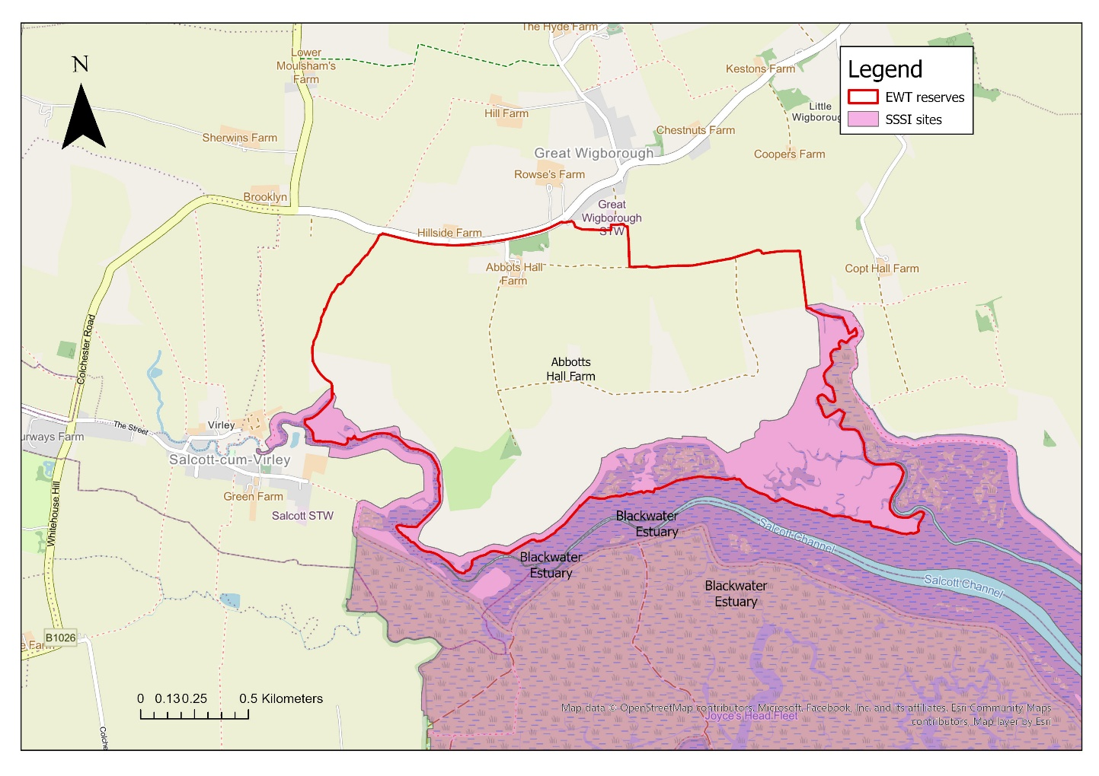
Figure 1: Location of work at Abbotts Hall, Great Wigborough, Colchester, Essex C05 7R

Document C: Specification of Goods/Services

We are seeking competitive prices for the installation of approximately 9,000m of livestock fencing, field and pedestrian gates, livestock corrals and livestock handling areas.

The contract will commence in spring 2026.

All fencing must conform to Essex Wildlife Trusts (EWT) fencing specification as outlined in Appendix 1.

Bill of Quantities

Prices should be inclusive of all materials and labor and include:

- Existing fence removal with waste removed and disposed of offsite. The approximate length of fence to be removed is 2,200m. The existing fence to be removed is standard stock fence.

- Vegetation management along the new fence line as required. Please provide a per m quote for small scrub and larger scrub and trees. The approximate length of removal is 50m. Please note that this must not be carried out within nesting bird season without approval and appropriate ecological surveys.

- Installation of new fencing to the EWT specification. Please provide per m cost and total cost:
  - Woodland edge fencing: 560m
  - Field edge fencing: 8,500m
Material costs to include:
    - Sheep netting and wire as per EWT specification
    - Intermediate chestnut posts as per EWT specification. Please include approximate number of posts required.
    - Chestnut strainers, turners (allowing for 4 per 100m for open edges and 6 per 100m for wooded sections). Please include approximate number required
    - Post and rail timber for gate and fence junctions
    - 32 galvanized half mesh field gates to be installed as per EWT specifications. Hanging/slammer posts and fixings to be included in the price. Please note this excludes the cattle handling system gates and infrastructure.
    - 4 large pedestrian gates
    - Two livestock corrals (one per enclosure) consisting of two pens (approx..20m by 30m).
    - A livestock handling system. The system is to be integrated with one of the corrals. Design subject to detailed and further design.
  - Installation and supply of badger access gates. Please allow for 2 per 100m.

Maps and designs

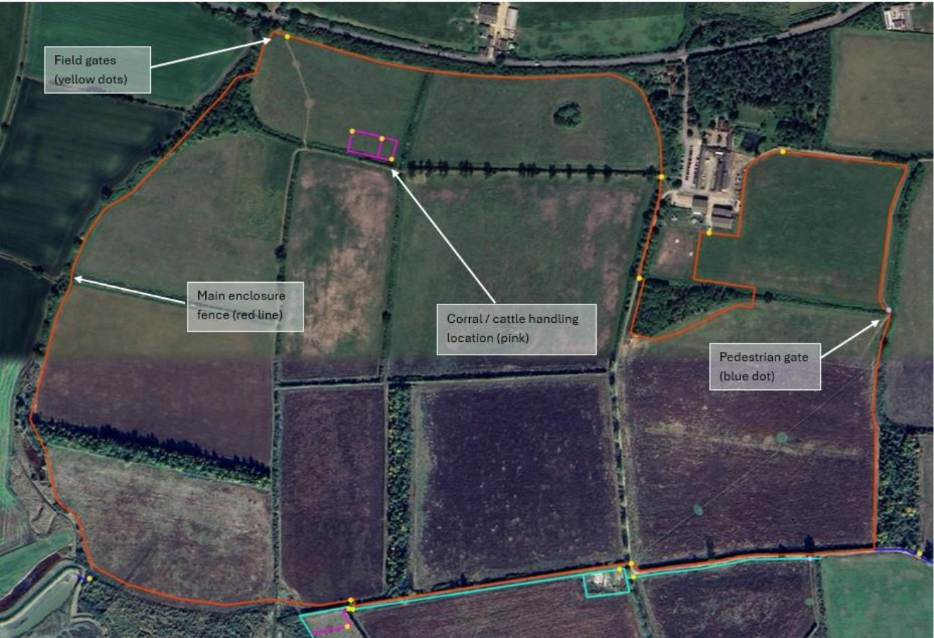
Map One: Main Enclosure (Red Line)
4460m fencing (c4230m field edge, c230m scrub/woodland, 3 ditched hedge crossings), 10 field gates (yellow dots), 1 pedestrian gate (blue dot), corral and cattle handling area (pink, see tender specification). 200m stock fencing to be removed (see map four).

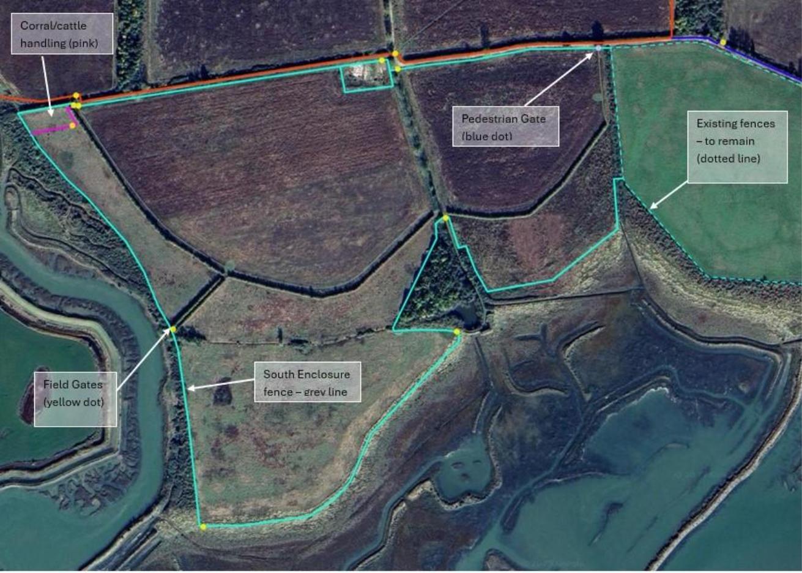
Map Two: South Enclosure (Grey Line)
2600m fencing (c2270m field edge, c330m scrub/woodland, 1 ditched hedge crossing), 9 field gates (yellow dots), 1 pedestrian gate (blue dot), corral and cattle handling area (pink). 2000m stock fencing to be removed (see map four).

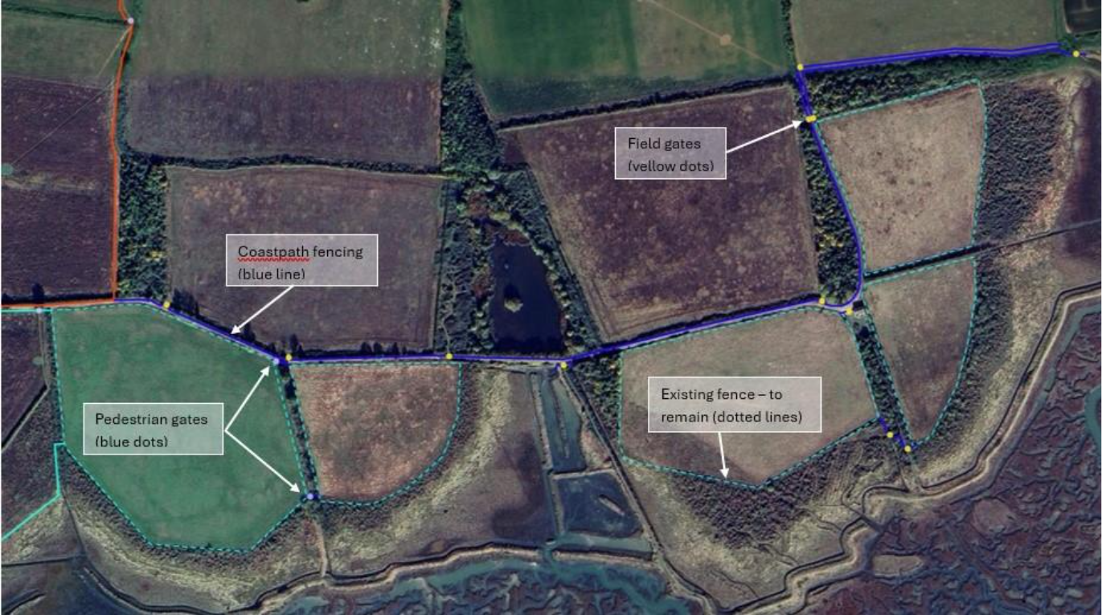

Map Three: Coastpath Fencing (Blue Line)
2000m fencing in two main runs with smaller additional areas, all field/path edge or on former seawalls, 13 field gates (yellow dots), 2 pedestrian gates (blue dots)

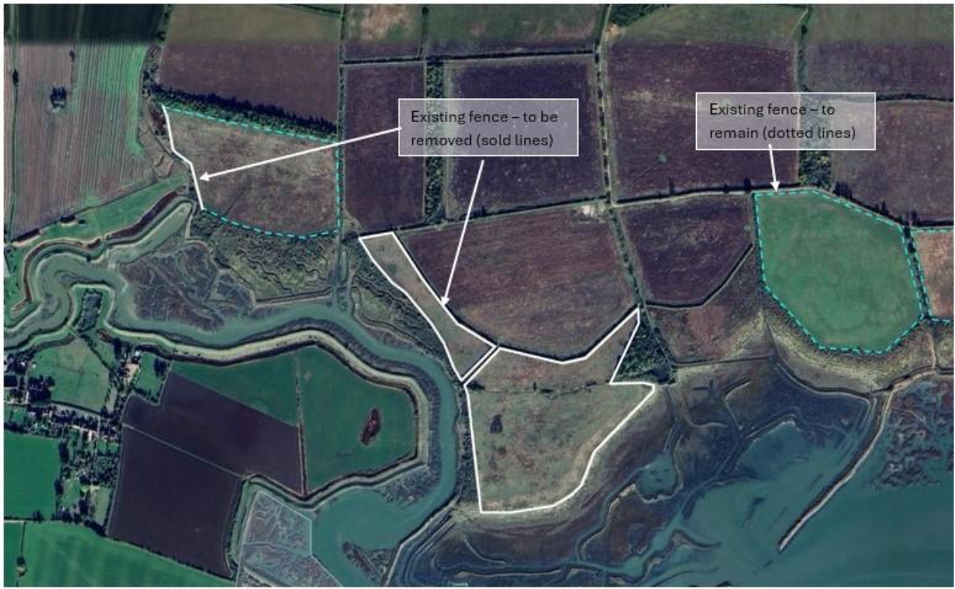
Map Four: Fencing to be removed
2200m stock fencing to be removed

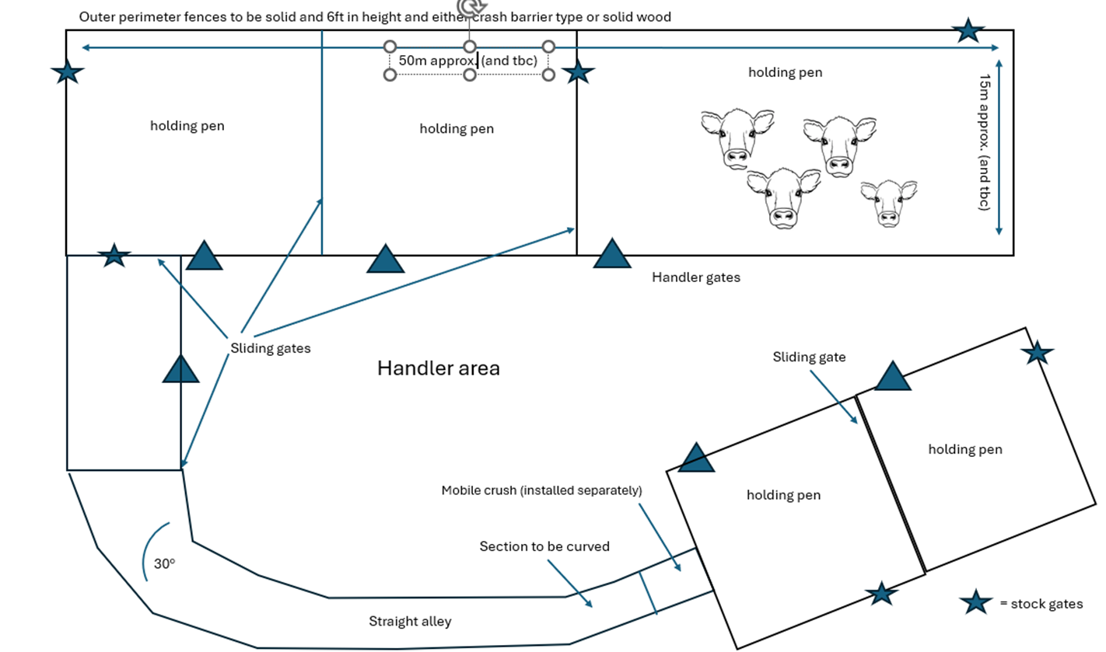
Figure 2: Approximate design of the cattle handing system and subject to detailed and further design

Document D: Company Information

 | 1.0 | General
 | 1.1 | Registered Name  Trading Name (if different)
 | 1.2 | Correspondence Details  Name of person applying on behalf of the company  Address:  Telephone:  Mobile:  Email:
 |  | Registered office Address (if different from above)
 | 1.3 | Company Registration No (if applicable)  VAT registration number (if applicable)
 | 1.4 | Date company was founded (if a limited company, date of incorporation)
 | 1.5 | Company structure and nature of company  Please outline the nature of the company, whether it is a partnership, sole trader, plc etc.  Is the company proposed as party to the contract part of a larger organisation? If so please explain the relationship between the various parts of the organisation, up to the ultimate holding company.  Current number of full time equivalent staff currently employed by the company (not larger parent company)
 | 1.6 | Accreditation by / Membership of Trade Association(s)  Is your Company registered with any industry accreditation body? YES NO  If yes, please provide details:  Is your Company on any public sector Framework agreements? YES NO  If yes, please provide details:  Please state membership of any professional bodies/ other associations below:
 | 1.7 | Quality Assurance  Is all / part of your company ISO9001 Quality Assured? YES NO  Is all / part of your company ISO14001 Quality Assured? YES NO  If yes please provide copy of certification  Do you have any other Quality Assurance? If Yes, please summarise details below
 | 1.8 | Environmental Commitments  Is all / part of your company registered under Science Based Targets (https://sciencebasedtargets.org/net-zero), Business Climate Hub (https://businessclimatehub.org/uk/) or equivalent? YES NO  If Yes, please summarise details below

 | 2.0 | Financial & Business Probity
2.1 |  | Judgements etc.  Are there any judgements, claims or suits pending or outstanding against your company?  Yes No If Yes, please provide full details  Has your company ever failed to complete a contract?  Yes No If Yes, please provide full details
2.2 |  | Please answer all of the following questions as they apply to your Company’s circumstances. Please confirm that:  1) being a company, no resolution has been passed or Order of the Court made for the company’s winding up otherwise than for the purposes of bona fide reconstruction or amalgamation, nor has a receiver, manager or administrator on behalf of a creditor been appointed in respect of the company’s business or any part thereof, nor is it the subject of any proceedings for any of the above procedures, nor is it the subject of similar procedures under the law of any other state.  Confirmed Not confirmed Non-applicable  2) being a partnership, it has not granted a trust deed or become otherwise apparently insolvent, or it is not the subject of a petition presented for sequestration of its estate.  Confirmed Not confirmed Non-applicable  3) being an individual, you are not bankrupt, or have not had a receiving order or administration order made against you, or have not made a composition or arrangement or trust deed with or for the benefit of your creditors, or have not made any conveyance or assignment for the benefit of your creditors, or have not had a petition presented for sequestration of your estate or do not appear to be able to pay or to have no reasonable prospect of being able to pay a debt within the meaning of the Insolvency Act or any similar procedure under the law of any EC member state.  Confirmed Not confirmed Non-applicable  4) no Directors, Partners, Associates or the Company Secretary have been involved in any Company which has been liquidated or gone into receivership.  Confirmed Not confirmed Non-applicable  5) none of the Directors, Partners, Associates or the Company Secretary have been convicted of a criminal offence relating to the conduct of their business or profession.  Confirmed Not confirmed Non-applicable  6) neither the Company nor any of the Directors, Partners, Associates or Company Secretary has committed an act of grave misconduct in the course of their business or profession.  Confirmed Not confirmed Non-applicable  7) all obligations relating to the payment of taxes under the law of any part of the United Kingdom or the EC member state in which the Company is established has been fulfilled  Confirmed Not confirmed Non-applicable  8) all obligations relating to the payment of social security contributions under the law of any part of the United Kingdom or the EC member state in which the Company is established have been fulfilled.  Confirmed Not confirmed Non-applicable  If you have ticked ‘Not confirmed’ for any questions above please give details here

2.3 | Please list the names of any Director, Partner, Associate or Company Secretary who have been employed by EWT, giving department and dates.  Please give details of any Director, Partner, Associate or Company Secretary who have a relative who is employed by EWT at a senior level.  Please list the names of any Director, Partner, Associate or Company Secretary who have any involvement in other Companies who provide services to EWT  Is any work being undertaken or likely to be undertaken during the next three years by the Company or staff within it which could give rise to a conflict of interest through acting for third parties or otherwise? If yes, please explain the actual or likely circumstances and how such potential conflicts of interest would be handled.

2.4 | Insurances (a scanned copy of each certificate will be requested)
 |  | Insurer | Policy No | Value of Cover | Expiry Date
 | Employers Liability
 | Public Liability
 | Prof. Indemnity
All Risks
(if applicable)

2.5 | Has your company (or any building/project you have undertaken) won any awards, accolades or recognition?  YES NO If yes please provide full details.

3.0 | Health & Safety and Environment
3.1 | Has your company been served with any enforcement or prohibition notices or been prosecuted in the past 5 years for breaches of health & safety legislation?  YES NO If yes please provide full details.
3.2 | Has your company been served with any enforcement or prohibition notices or been prosecuted in the past 5 years for breaches of environmental legislation?  YES NO If yes please provide full details.
3.3 | Has your company been served with any enforcement or prohibition notices or been prosecuted in the past 5 years for breaches of data protection legislation?  YES NO If yes please provide full details.
3.4 | Have any restrictive clauses in relation to your company’s Employer’s Liability, Public Liability or Professional Indemnity Insurance policies been enforced in the last 5 years due to past Health & Safety performance?  YES NO If yes please provide full details.

Document E: Form of Offer
Cost

Cost for providing goods/services, as outlined in specifications (Document C). Please provide a breakdown as required.
- Existing fence removal | £
- Vegetation management | £
- Installation of new fencing | Total: £
- Netting and wire | £
- Chestnut posts | No.: £:
- Strainers and turners | No.: £:
- Post and rail for junctions | £
- 32 field gates | £
- 4 pedestrian gates | £
- 2 livestock corrals | £
- 1 livestock handling system (indicative as subject to final design) | £
- Badger access gates | £
SUM TOTAL (ex. VAT)
SUM TOTAL (inc. VAT)

Added Value
As well as any charity rate that you may be able to offer, EWT is always open to corporate partnerships that deliver benefit to your organisation, EWT and nature. Working as part of your CSR agenda we can provide opportunities for fundraising and volunteering, offering your staff both personal and career development opportunities. We also welcome all forms of gifts in kind as valuable contributions to our work.

Suppliers should provide details of any associated added value features/services/gifts in kind available to EWT under the terms of this Tender. (Attach separate document if needed).

Please note, added value donations will not be part of the criteria we use to decide on which supplier to choose.

Approach to the Project

What would be your approach to this project (include method statements, risk assessment etc.)? (Attach separate document if needed)

After sales service
Please indicate details of any warranty period associated with the goods / service, and how any such work will be carried out. Include details of contingency planning in case of disaster (such as fire, strikes, flooding etc). (Attach separate document if needed)

References
Suppliers are requested to provide details of three references from their existing clientele, supplying full name, address, telephone number, email address, contact name, period of Contract and the estimated annual value of the Contract. In supplying this information, Suppliers shall have granted EWT permission to seek such information as deemed necessary, in relation to the Suppliers performance with their nominated references.

Reference 1
Company Name
Address
Telephone No |  | Ext
Email
Contact |  | Dates of work
Nature of work done |  | Value of contract

Reference 2
Company Name
Address
Telephone No |  | Ext
Email
Contact |  | Dates of work
Nature of work done |  | Value of contract

Document F: Certificate of Bona Fida Offer

We certify that this offer is made in good faith, and that we have not fixed or adjusted the amount of the offer by or under or in accordance with any agreement of arrangement with any other person. We also certify that we have not, and we undertake that we will not:

1 a) communicate to any person other than the person inviting these offers the amount or approximate amount of the offer or proposed offer, except where the disclosure, in confidence, of the approximate amount of the offer was necessary to obtain insurance quotations required for the preparation of the offer;
b) enter into any agreement with any other person that s/he shall refrain from making an offer or as to the amount of any offer to be submitted;

2 pay, give or offer or agree to pay or to give any sum of money or other valuable consideration directly or indirectly to any person for doing or having done or causing or having caused to be done in relation to any offer or proposed offer for the goods/services any act or thing of the sort described in 1 a) or 1 b) above.

We acknowledge that if we acted or shall act in contravention of this certificate, EWT will be entitled to cancel the agreement and to recover from ourselves the amount of any loss and expense resulting from such cancellation.

I state that everything in this tender submission is truthful, that if found to be untruthful EWT can terminate any agreement between EWT and the company formed on the basis of this tender, and we will pay to EWT any loss or expenses EWT suffers as a result of such untruthfulness, whether an agreement is entered into or not.

In this certificate, the word “person” includes any persons and any body or association, corporate or unincorporated; “any agreement or arrangement” includes any transaction, formal or informal, and whether legally binding or not.

Signed
On behalf of
Date

Please note: a name added in an electronic document is functionally equivalent to a signature.

Appendix 1: Essex Wildlife Trust Fencing Specification

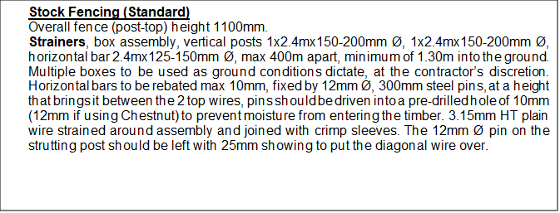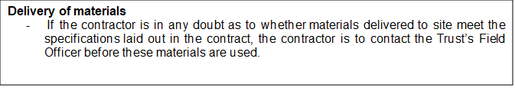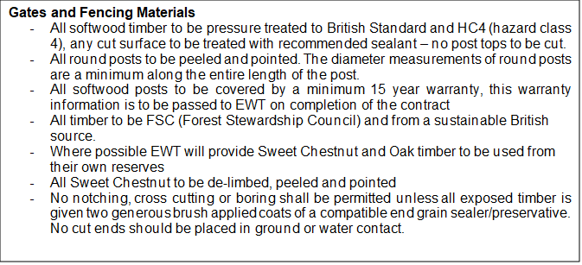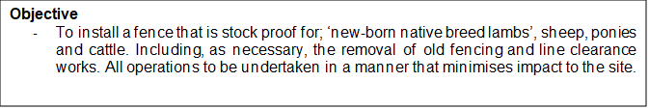
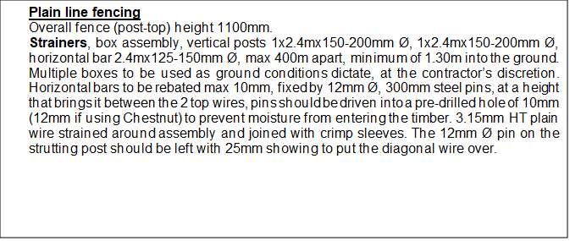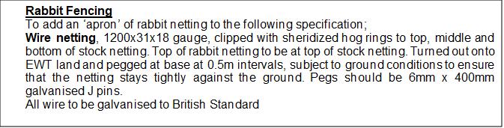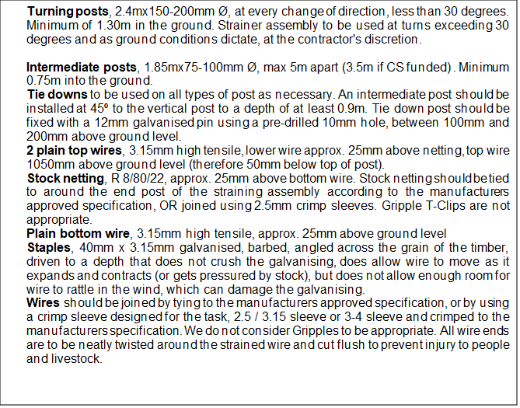
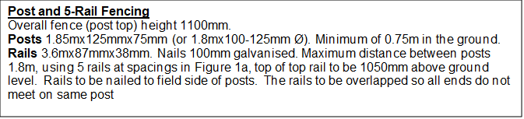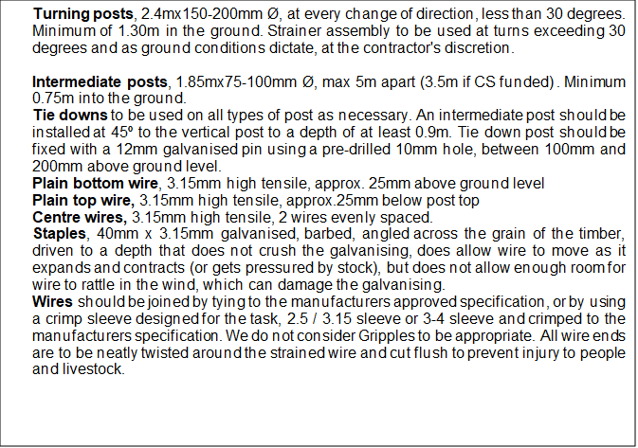Fig. 1a
